Summer internship 2021

Task 2:

Task Description 📄

📌 GUI container on the Docker

🔅 Launch a container on docker in GUI mode

🔅 Run any GUI software on the container

Requirements:

Xauth allows to connect a display server with the container.

Procedure:

* From the last task, I created my own custom docker image, as the last installed programs are there in order no to waste my mobile data, through the following command on my based Rhel8:

# docker commit -m "First commit of sumerdock" -a "Richard" SumerDock firstsumerimgcomit

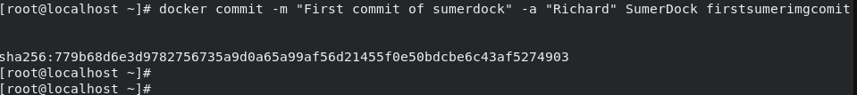

* After that, setup the Xauth cookies of my base Rhel through this command:

#xauth add :0 . `mcookie`

Let’s check if it is realy created:



* Now we will create a new container with an exposed port

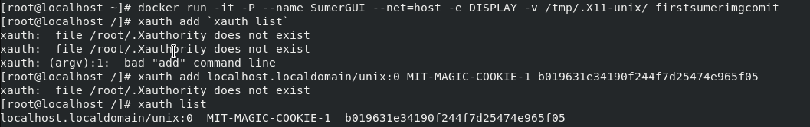

* And through the launching of the grapghical software here firefox, Xauth cookies is copied to the container and finally the gui of the application starts

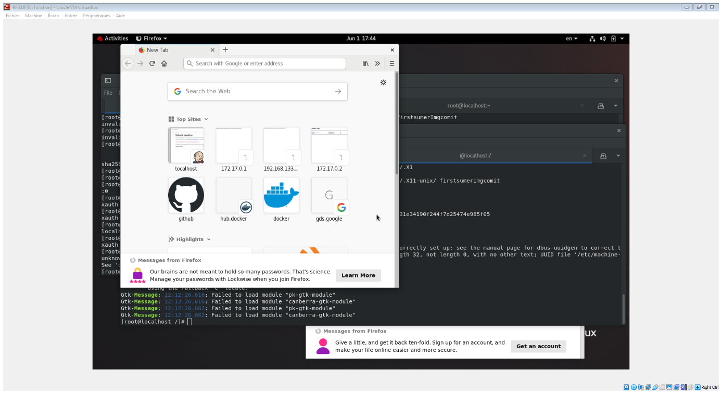

The difference might be not easily noticeable, but the command prompt change (the directory part in the prompt from ‘~’ To ‘/’ ), which is the proof of entering the container directly after starting the the container.

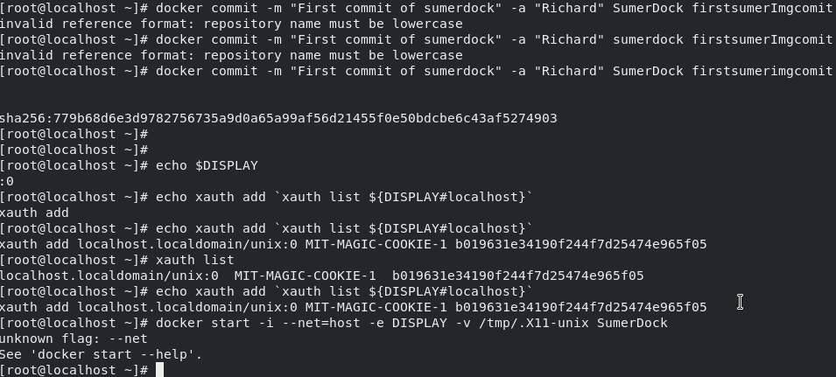

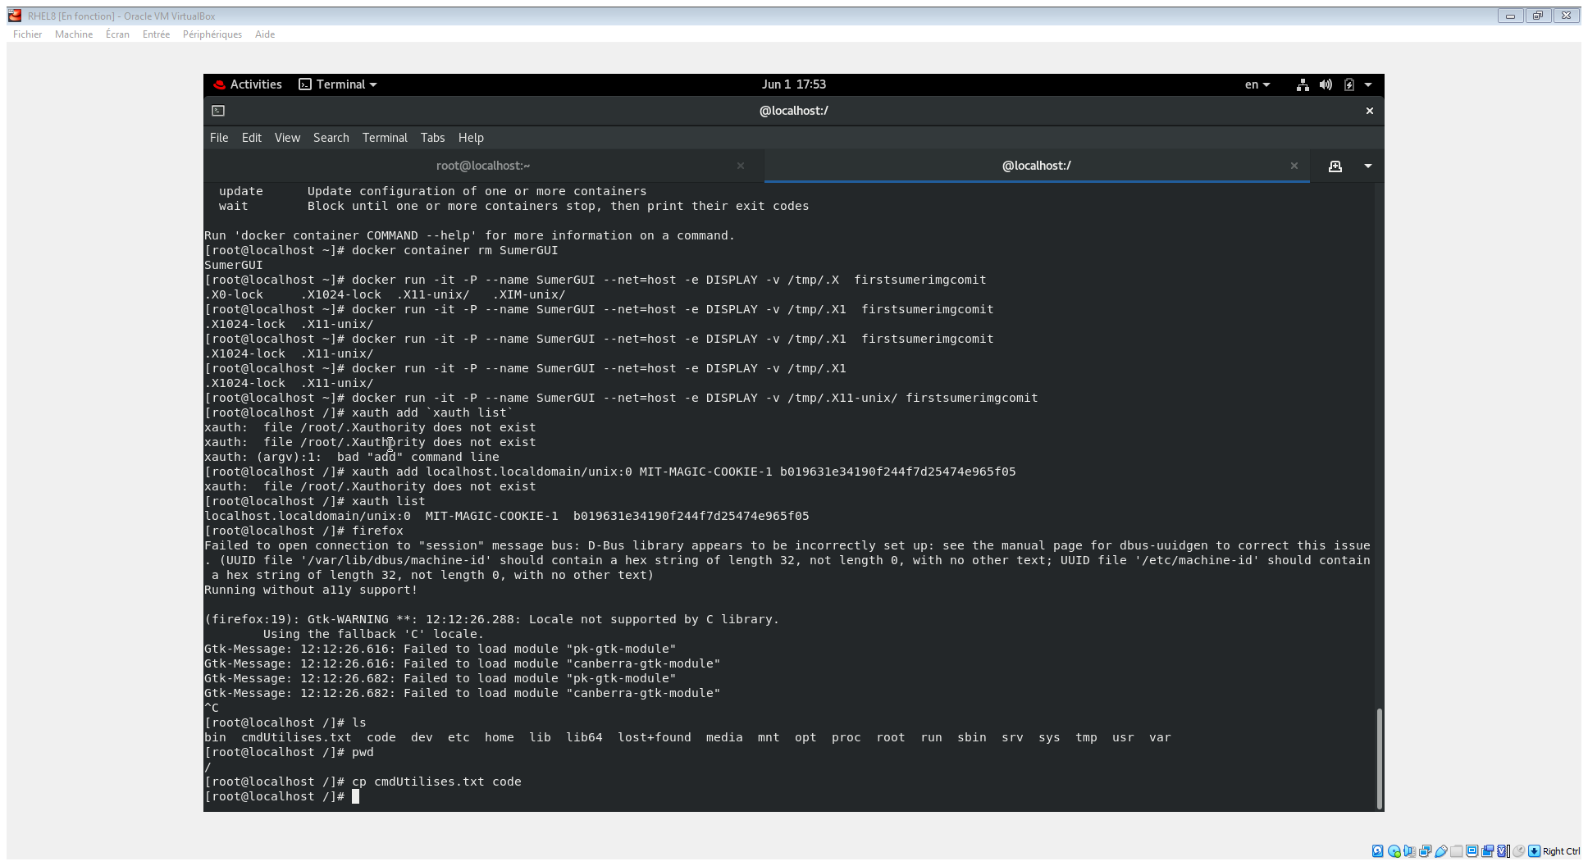

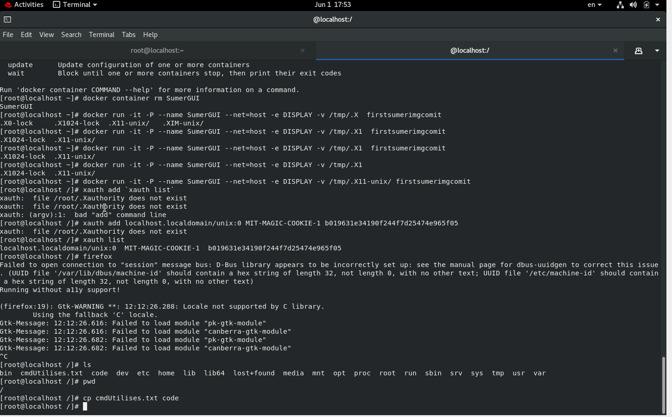

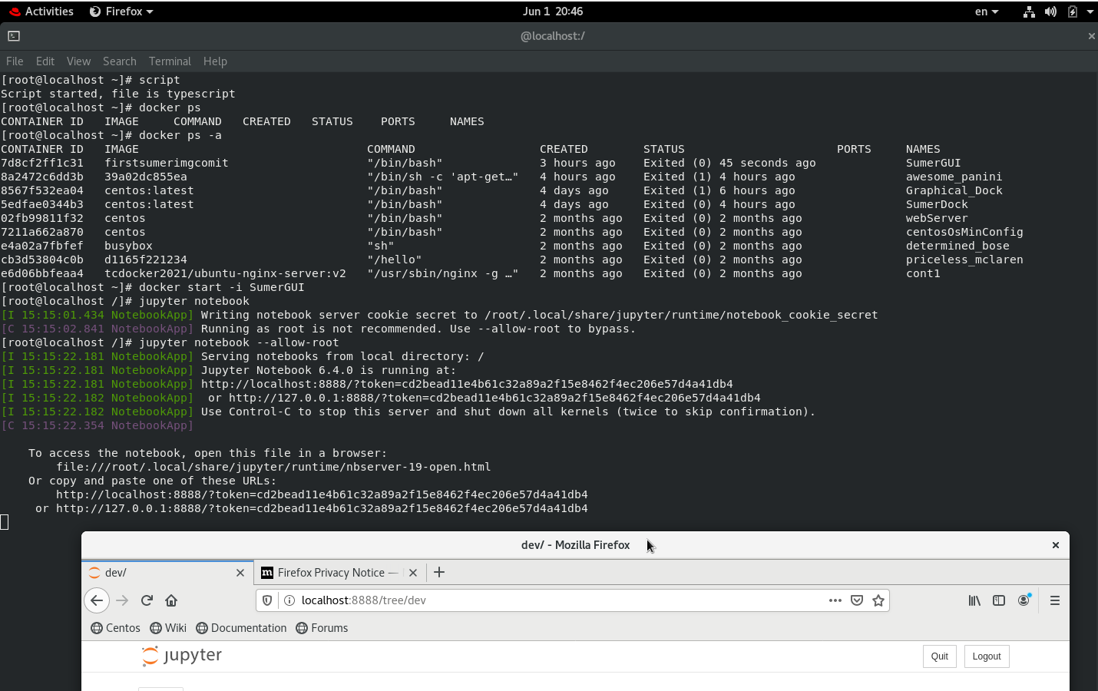

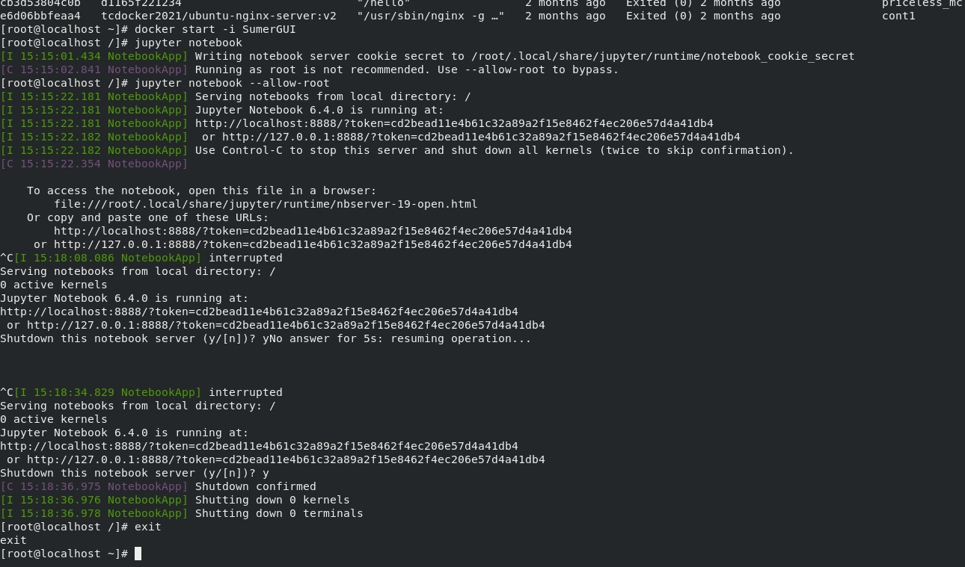

#vimaldaga #righteducation #educationredefine #rightmentor #worldrecordholder #linuxworld #makingindiafutureready #righeducation #arthbylw #docker #container